Introduction To Linux

Q] What is Operating System?
An Operating System (OS) is a software that acts as an interface between computer hardware components and the user. Every computer system must have at least one operating system to run other programs.
Applications like Browsers, MS Office, Notepad Games, etc., need some environment to run and perform its tasks.
The OS helps you to communicate with the computer without knowing how to speak the computer’s language.
It is not possible for the user to use any computer or mobile device without having an operating system.
OS is a the Combination of hardware and software
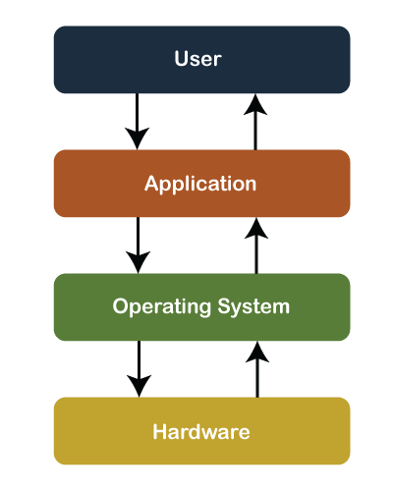

Key functions of an operating system include.
- Process Management: It manages the execution of processes or tasks, allocating resources such as CPU time, memory, and input/output devices to each process.
- Memory Management: The OS controls the allocation and deallocation of memory space to processes, ensuring efficient memory utilization and preventing conflicts between processes.
- File System Management: It provides a hierarchical organization of files and directories, and it facilitates operations such as file creation, deletion, reading, and writing.
- Device Management: The OS interacts with hardware devices such as keyboards, monitors, printers, and storage devices, managing device access and providing device drivers to enable communication between software and hardware.
- User Interface: Operating systems provide a user interface through which users interact with the computer system. This interface can be command-line based, graphical (GUI), or a combination of both.
- Security: OS provides mechanisms for user authentication(used by a server when the server needs to know exactly who is accessing their information or site.), access control, data encryption, and protection against malware and unauthorized access.
Examples of popular operating systems include Microsoft Windows, macOS, Linux, and Unix variants. Each OS has its own set of features, user interface, and compatibility with different software applications and hardware devices.

What is a Server?
A server is a computer program or device that provides a service to another computer program and its user, also known as the client.

Q] What is Unix?
Unix is a family of multitasking, multiuser computer operating systems that originated in the 1960s at AT&T Bell Labs.
It was developed by a group of researchers including Ken Thompson, Dennis Ritchie, and others.
Unix was designed to be portable, multitasking, and multiuser, making it suitable for a wide range of computing environments.

Linux from the beginning – History and Evolution

In this article, we will discuss the history and evolution of the Linux Operating System.
But before jumping into the history of Linux we must pass through UNIX.

History of UNIX :
It started in 1964 in New Jersey when some people of Bell Labs tried to create a multiuser operating system (OS), they worked on it till 1969, after facing lots of failures they withdraw the project.
Then a group of five people including Dennis Ritchie and Ken Thompson successfully created an operating system called UNICS ( Uniplexed Information and Computing Service), better known as UNIX. They publish this OS as open-source (free to use and edit the codebase).
In 1975 a version of UNIX was released labeled “UNIX v6”, it became very popular.
Some companies tried to make a profit from it, so they made their own commercial version or flavor of UNIX :
- IBM – AIX
- Sun Solaris
- Mac OS
- UP UX

Why Linux was created?
Linus Torvalds is the creator of the Linux kernel. In simple words, Linus Torvald created Linux because he didn’t have money to buy UNIX. He was a student at the *University of Helsinki*.
In early 1991 he decided to do a project on UNIX, but free versions of UNIX were too old and other commercials are too costly ($5000). So he thought of creating his own OS.
Now one question may arise that is Linux an exact copy of UNIX?
Actually not, let us clear this for you.
For idea purpose, Linus did research on UNIX, but more than UNIX he did research on MINIX OS.
And no, Linux is not an exact copy of UNIX.

What is MINIX?
MINIX was created by Andrew S. Tanenbaum on 1987. MINIX is a Unix-like operating system based on a microkernel architecture.
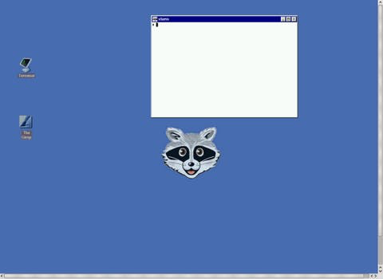
Minix OS
The main reason behind creating MINIX is to teach his students and the book he was writing Operating Systems Design and Implementation.
Fact: MINIX is a text-oriented operating system with a kernel of fewer than 6,000 lines of code.

After Linux developed!
So finally Linux was released on September 17, 1991. Linus made it open source. Between 1991 to 1995, Richard Stallman started a movement called the “Free Software Movement“, and created the GNU project (collection of free software).
Linux is a kernel and not an operating system and GNU is a collection of free software, these two project collabs give us “Linux” or “GNU/Linux” operating system. Some companies and open source communities adopt GNU/Linux codebase, did some modifications, and created their own version or distributions,
Example:
- RHEL (Red hat)
- Fedora
- Debian
- Ubuntu
- CentOS
- Kali Linux

Point to be Noted:
- Linux is a kernel, not OS.
- Linux is not a UNIX clone, it was written from scratch.
- A Linux distribution is the Linux kernel and a collection of software that together creates an OS.

Features or Linux or Why Linux is so popular?
Linux is so much popular that most IT companies ask their candidates that “Do they have knowledge or experience of Linux-based OS?”.
Some points are mentioned below of the reason behind why it’s so popular / Features :
- Open Source
- Lightweight
- Secure
- Multiuser – Multitask
- Simplified update for all installed software
- Multiple distributions ( RedHat, Debian, etc)

Linux Features

- Multiuser capability: Multiple users can access the same system resources like memory, hard disk, etc. But they have to use different terminals to operate.
- Multitasking: More than one function can be performed simultaneously by dividing the CPU time intelligently.
- Portability: Portability doesn't mean it is smaller in file size or can be carried in pen drives or memory cards. It means that it support different types of hardware.
- Security: It provides security in three ways namely authenticating (by assigning password and login ID), authorization (by assigning permission to read, write and execute) and encryption (converts file into an unreadable format).
- Live CD/USB: Almost all Linux distros provide live CD/USB so that users can run/try it without installing it.
- Graphical User Interface (X Window system): Linux is command line based OS but it can be converted to GUI based by installing packages.
- Support's customized keyboard: As it is used worldwide, hence supports different languages keyboards.
- Application support: It has its own software repository from where users can download and install many applications.
- File System: Provides hierarchical file system in which files and directories are arranged.
- Open Source: Linux code is freely available to all and is a community based development project.

.NO | Linux | Windows
1. | Linux is a open source operating system. | While windows are the not the open source operating system.
2. | Linux is free of cost. | While it is costly.
3. | It’s file name case-sensitive. | While it’s file name is case-insensitive.
4. | Linux is more efficient in comparison of windows. | While windows are less efficient.
5. | There is forward slash is used for Separating the directories. | While there is back slash is used for Separating the directories.
6. | Linux provides more security than windows. | While it provides less security than linux.
7. | Linux is widely used in hacking purpose based systems. | While windows does not provide much efficiency in hacking.
8. | There are 3 types of user account –  (1) Regular , (2) Root , (3) Service account | There are 4 types of user account –  (1) Administrator , (2) Standard , (3) Child , (4) Guest
9. | Root user is the super user and has all administrative privileges. | Administrator user has all administrative privileges of computers.
10. | Linux file naming convention in case sensitive. Thus, sample and SAMPLE are 2 different files in Linux/Unix OS. operating system. | In Windows, you cannot have 2 files with the same name in the same folder.

Introduction to Linux Distribution
But Linux is different from them. Different parts of Linux are developed by different organizations.
Different parts include kernel, shell utilities, X server, system environment, graphical programs, etc. If you want you can access the codes of all these parts and assemble them yourself. But its not an easy task seeking a lot of time and all the parts has to be assembled correctly in order to work properly.
From here on distribution (also called as distros) comes into the picture. They assemble all these parts for us and give us a compiled operating system of Linux to install and use.
- A Linux distribution is an OS made through a software collection that contains the Linux kernel and a package management system often.
- Distribution is actually design according to user need.

Linux Distributions List
There are on an average six hundred Linux distributors providing different features. Here, we'll discuss about some of the popular Linux distros today.

1) Ubuntu

2) Linux Mint

3) Debian

4) Red Hat Enterprise / CentOS

5) Fedora

Version of Red Hat Enterprise Linux.

- RHEL 5.0 = Red Hat Enterprise Linux 5.0
- And its latest version of RHEL is 9.0

Architecture of Linux system

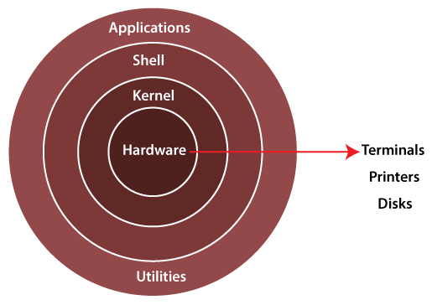[

The Architecture of a Linux System Consists of the following layers.
- Hardware Layer :- Hardware consists of all peripheral device (RAM/HDD/CPU etc).
- Kernel :- It is a core component of Operating System, interacts directly with hardware and software.
It is also known as Heart of Lunix.
- Shell :- A Shell is a interpreter that acts as an interface between the user and operating system.
The Shell takes commands from the users and executes kernels functions.
Popular shells include BASH (Bourne Again Shell), Zsh (Z Shell) and Fish (Friendly Interactive Shell).

- Utilities :- Utilities refers to small software programs or commands that perform specific task or function.
Linux utilities cover a wide range of functionalities, including file manipulation (e.g. copy, move, delete),
Text processing (e.g. search, replace, format).

Disadvantages of Linux

- It is not very user-friendly. So, it may be confusing for .beginners.

- Games :-
Most of the games are made for windows but not Linux. As windows platform is widely used so game developers have more interest in windows.
- Entertainment.

What Does a Linux Engineer Do?
A Linux engineer works in the IT field designing, implementing, and managing Linux-based operating systems. An engineer working with Linux is responsible for installing, configuring, maintaining, and supporting Linux servers, networks, and applications.

